Date: -24/10/26
CO-2 Assessment-2
SCENARIO BASED PROBLEM
Course Code: -DSA 0308
Course Name: -Natural Language Processing
Name: -A.V. Ameya Reg no: -192472036

QUESTION 2: MORPHOLOGICAL ANALYSIS OF AGREE WORDS
Aim
To develop a Python program that identifies prefixes, roots, and suffixes in the words "disagree", "agreement", and "agreeable" and normalizes them to a common base word.
Introduction
Morphology is a branch of Natural Language Processing (NLP) that studies the structure and formation of words. Words can contain a root along with prefixes and suffixes. These additions can change the meaning or grammatical role of a word.
In this program, the words "disagree", "agreement", and "agreeable" are analyzed using rule-based morphological processing. The root word is identified as "agree", and the words are normalized to a common representation. This approach helps text processing systems identify related words efficiently.
Objectives
- To identify the root word in each input.
- To detect prefixes and suffixes.
- To classify the words as derivational forms.
- To understand how affixes affect word meaning.
- To normalize related words to a common base representation.
Algorithm
- Start the program.
- Store the input words in a list.
- Check each word using predefined morphological rules.
- Identify the prefix, root, and suffix.
- Classify each word as a derivational form.
- Normalize each word to the root "agree".
- Display the morphological analysis.
- Stop the program.
Program Description
The program uses predefined rules to analyze three English words. The word "disagree" contains the prefix "dis", which expresses an opposite meaning. The word "agreement" contains the suffix "ment", which forms a noun. The word "agreeable" contains the suffix "able", which forms an adjective.
All three words share the root "agree". The program displays the original word, prefix, root, suffix, transformation type, and normalized word.
Morphological Analysis
Word 1: Disagree
- Prefix: dis
- Root: agree
- Suffix: None
- Transformation: Derivational
- Meaning: To have a different opinion or not share the same view.
Word 2: Agreement
- Prefix: None
- Root: agree
- Suffix: ment
- Transformation: Derivational
- Meaning: A state of sharing the same opinion or reaching a decision.
Word 3: Agreeable
- Prefix: None
- Root: agree
- Suffix: able
- Transformation: Derivational
- Meaning: Pleasant or acceptable.
Applications
- Sentiment analysis systems.
- Search engines and information retrieval.
- Text classification.
- Document processing.
- Natural Language Processing applications.
Conclusion
The program successfully demonstrates rule-based morphological analysis for the words "disagree", "agreement", and "agreeable". It identifies their common root and separates their prefixes or suffixes. Normalizing the words to "agree" helps group related word forms during text processing. However, the normalized root does not preserve all the differences in meaning, so sentiment analysis systems may need additional semantic analysis.

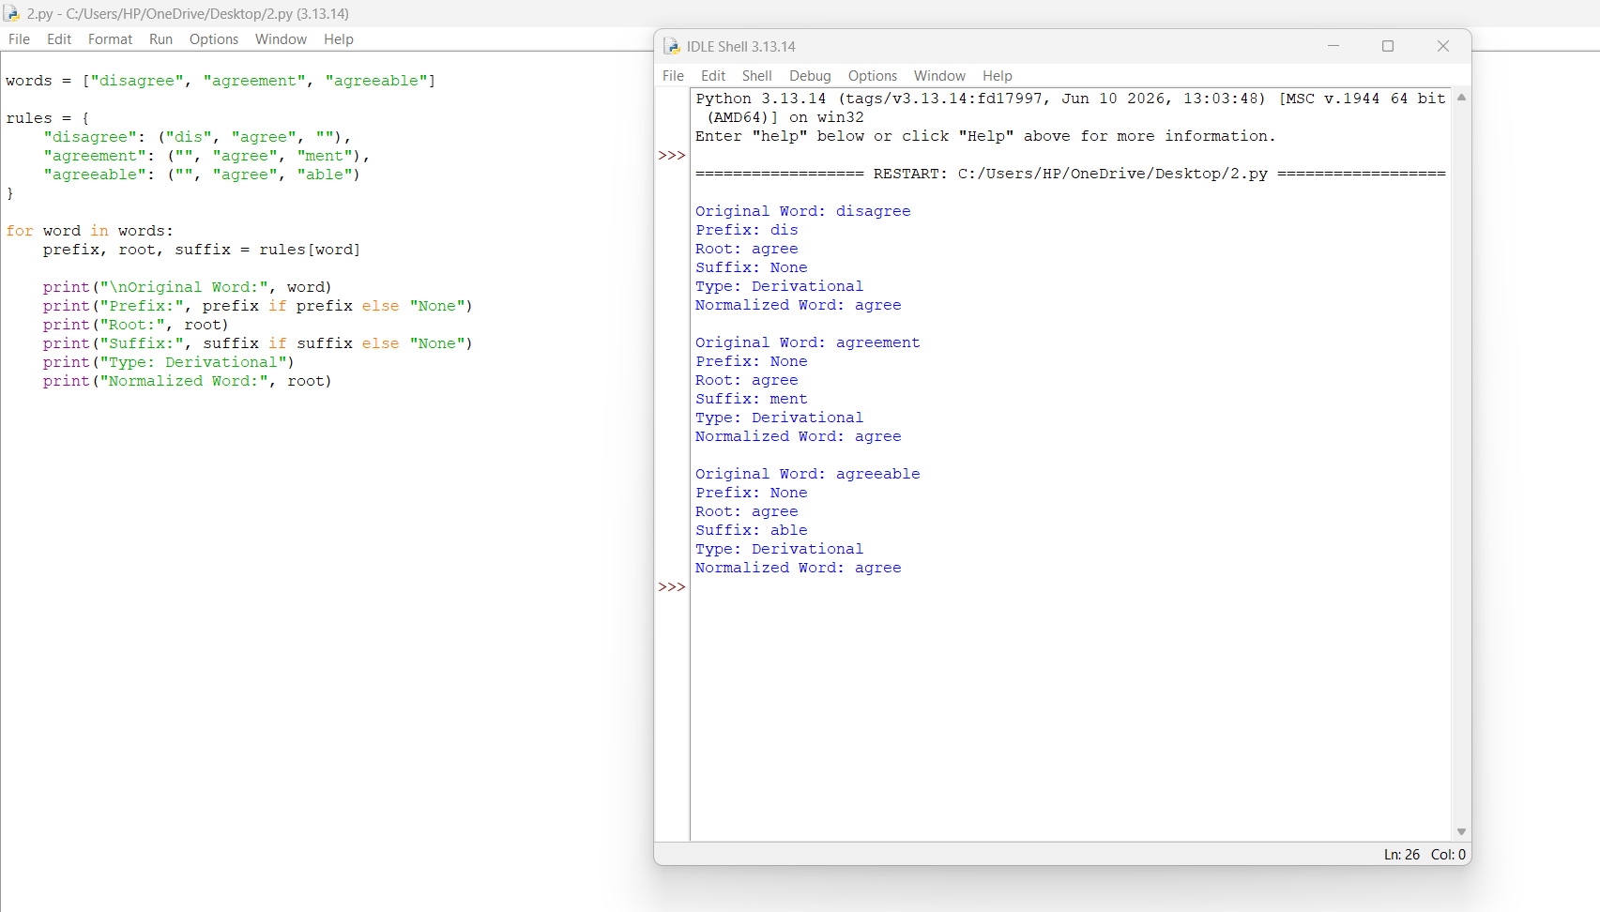

QUESTION 5: INFLECTIONAL MORPHOLOGY OF CREATE WORDS
Aim
To develop a Python program that identifies prefixes, roots, and suffixes in the words "disagree", "agreement", and "agreeable" and normalizes them to a common base word.
Introduction
Morphology is a branch of Natural Language Processing (NLP) that studies the structure and formation of words. Words can contain a root along with prefixes and suffixes. These additions can change the meaning or grammatical role of a word.
In this program, the words "disagree", "agreement", and "agreeable" are analyzed using rule-based morphological processing. The root word is identified as "agree", and the words are normalized to a common representation. This approach helps text processing systems identify related words efficiently.
Objectives
- To identify the root word in each input.
- To detect prefixes and suffixes.
- To classify the words as derivational forms.
- To understand how affixes affect word meaning.
- To normalize related words to a common base representation.
Algorithm
- Start the program.
- Store the input words in a list.
- Check each word using predefined morphological rules.
- Identify the prefix, root, and suffix.
- Classify each word as a derivational form.
- Normalize each word to the root "agree".
- Display the morphological analysis.
- Stop the program.
Program Description
The program uses predefined rules to analyze three English words. The word "disagree" contains the prefix "dis", which expresses an opposite meaning. The word "agreement" contains the suffix "ment", which forms a noun. The word "agreeable" contains the suffix "able", which forms an adjective. All three words share the root "agree". The program displays the original word, prefix, root, suffix, transformation type, and normalized word.
Morphological Analysis
Word 1: Disagree
- Prefix: dis
- Root: agree
- Suffix: None
- Transformation: Derivational
- Meaning: To have a different opinion or not share the same view.
Word 2: Agreement
- Prefix: None
- Root: agree
- Suffix: ment
- Transformation: Derivational
- Meaning: A state of sharing the same opinion or reaching a decision.
Word 3: Agreeable
- Prefix: None
- Root: agree
- Suffix: able
- Transformation: Derivational
- Meaning: Pleasant or acceptable.
9. Applications
- Sentiment analysis systems.
- Search engines and information retrieval.
- Text classification.
- Document processing.
- Natural Language Processing applications.
Conclusion
The program successfully demonstrates rule-based morphological analysis for the words "disagree", "agreement", and "agreeable". It identifies their common root and separates their prefixes or suffixes. Normalizing the words to "agree" helps group related word forms during text processing. However, the normalized root does not preserve all the differences in meaning, so sentiment analysis systems may need additional semantic analysis.

